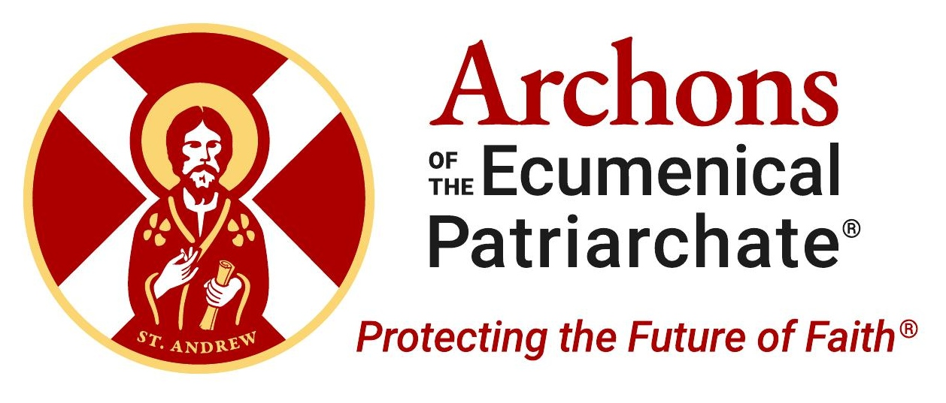 | PARISH MONTHLY BULLETIN  Archon Sunday • 2026

Protecting the Future of Faith
The Sacred Mission of the Archons and the Ecumenical Patriarchate

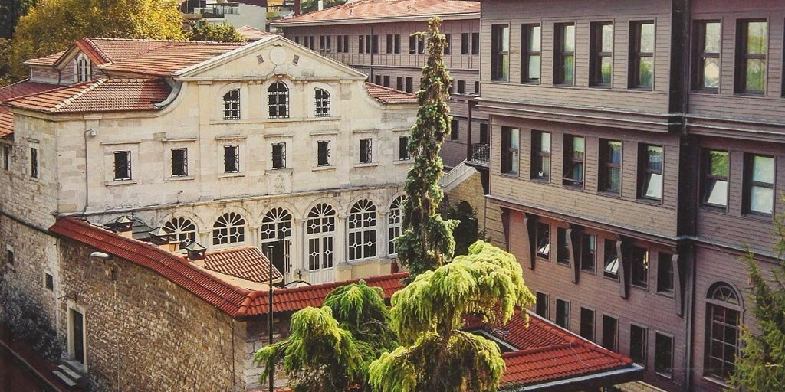
The Ecumenical Patriarchate of Constantinople — the historic spiritual center of worldwide Orthodoxy, located in the Phanar district of Istanbul.
On this Archon Sunday, we bring you warm greetings from His All-Holiness Ecumenical Patriarch Bartholomew, His Eminence Archbishop Elpidophoros of America, and our National Commander, Archon Anthony J. Limberakis.
Every year on Archon Sunday, our parish pauses to reflect on something larger than ourselves — the sacred mission of the Ecumenical Patriarchate and our shared responsibility as Orthodox Christians to support the Mother Church of Constantinople. This year, that reflection carries special weight.
The Ecumenical Patriarchate has stood for nearly seventeen centuries as the spiritual center of worldwide Orthodoxy. Through empires, wars, exile, and persecution, it has endured — not because of political power, but because it is rooted in Christ. Today, that endurance is being tested as never before, and the Archons of the Ecumenical Patriarchate are at the forefront of its defense.
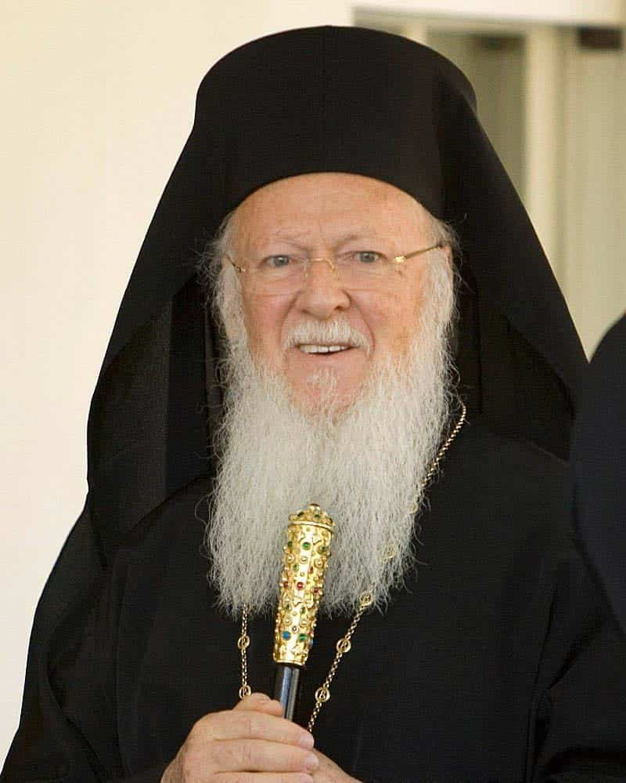  His All-Holiness Ecumenical Patriarch Bartholomew, spiritual leader of the world’s 300+ million Orthodox Christians. | Who Are the Archons?  The Archons of the Ecumenical Patriarchate are recognized lay leaders of the Orthodox Church who use their standing to advocate with world leaders, honored by His All-Holiness Ecumenical Patriarch Bartholomew for service to the Faith. But their role is far more than an honor — it is a calling, a call to duty in defense of the Faith.  They are committed to protecting religious freedom and ensuring the survival and flourishing of the Ecumenical Patriarchate — the spiritual center of the world’s more than 300 million Orthodox Christians. They are, in many ways, the last line of defense preventing what His All-Holiness has described as the “asphyxiation” of the Mother Church.  For nearly seventeen centuries, the Ecumenical Patriarchate has preserved the unity, order, and continuity of Orthodoxy through empires, wars, persecution, and exile. The Archons stand as defenders of that sacred legacy.
“The Archons exist to ensure that the Mother Church is never isolated, never silenced, and never forgotten.”
What Does “Ecumenical” Really Mean?
The word comes from the Greek oikoumene — “the whole inhabited world.” The Ecumenical Patriarch is not merely the bishop of a local Greek minority in Istanbul. He is the first among equals — primus inter pares — serving as the spiritual center of unity and coordination for all of worldwide Orthodoxy. There is only one Ecumenical Patriarch among all the Patriarchates, and that unique, universal title has always run with the land of Constantinople itself.
His canonical responsibilities include convening pan-Orthodox councils, mediating disputes between Churches, and granting autocephaly when pastorally necessary. Nearly every modern autocephalous Church traces its recognition, directly or indirectly, through the Ecumenical Patriarchate of Constantinople.
This universal role is recognized well beyond the Orthodox world. At a recent papal inauguration, Patriarch Bartholomew was seated in a place of honor above the College of Cardinals. One of the new Pope’s first international visits was to Constantinople itself.
Why Constantinople Itself Matters
People sometimes ask: why not simply move the Patriarchate somewhere else? The answer is that Constantinople is not accidental to Orthodox Christianity — it is essential to it. The Ecumenical Patriarchate has remained in Constantinople continuously for seventeen centuries. It survived the fall of Byzantium, wars, expulsions, and political oppression — yet it remains there today. Its canonical status runs with the land of Constantinople itself — a status that cannot be transferred or recreated elsewhere.
If the Patriarchate were forced to leave, it would not simply be a relocation. It would represent the triumph of persecution and the erasure of one of Christianity’s oldest continuous spiritual centers. Its continued presence is a testimony to religious freedom, coexistence, and the enduring witness of Orthodoxy.
FIVE CHALLENGES FACING THE MOTHER CHURCH
• Religious freedom — the Ecumenical Patriarchate’s ability to function freely in Turkey.
• The Theological School of Halki — closed by Turkish authorities for more than fifty years.
• Patriarchal elections — severely restricted by Turkish law.
• Confiscation of properties — Church and Patriarchal properties seized over decades.
• Ecumenical status — Turkey’s persistent refusal to recognize the Patriarchate’s universal role.
A Threat From Within Orthodoxy
One of the most serious challenges today comes not from outside Orthodoxy, but from within it. The Moscow Patriarchate has increasingly aligned itself with the geopolitical ambitions of the Russian state — a dangerous fusion of church authority and political power.
This alignment became most visible after Patriarch Bartholomew exercised his canonical responsibility to grant autocephaly to the Orthodox Church of Ukraine — restoring ecclesiastical independence to millions of Orthodox faithful. Moscow’s response was hostility, political pressure, and an aggressive campaign to undermine the authority of Constantinople.
Russia’s Foreign Intelligence Service publicly attacked His All-Holiness, calling him “an antichrist in a cassock” and “a devil in the flesh.” The Patriarch of Moscow remained silent. We have seen religious language used to justify war. We have seen incursions into canonical territories in Ukraine and Africa. This is not a jurisdictional disagreement. It is a spiritual crisis.
“Orthodoxy was never meant to serve empire. The Gospel cannot be subordinated to political ideology.”
What the Ecumenical Patriarchate Stands For
Against all of this, the Ecumenical Patriarchate stands for conciliarity instead of coercion, reconciliation instead of domination, and dialogue, freedom of conscience, and unity in Christ. The struggle before us is ultimately about preserving a free and universal Orthodoxy — an Orthodoxy rooted in Christ and guided by spiritual leadership rather than political power.
HOW YOU CAN HELP
Pray — for His All-Holiness Ecumenical Patriarch Bartholomew, for the Mother Church, and for all those who labor in defense of religious freedom.
Stay informed — learn about the challenges facing the Ecumenical Patriarchate and share that knowledge with family, friends, and community members.
Support the mission — consider supporting the Ecumenical Patriarch Bartholomew Foundation, established to secure the long-term future of the Ecumenical Patriarchate. This is not simply philanthropy. It is an investment in the spiritual heart of our Faith.
A Hope Rooted in Christ
The Ecumenical Patriarchate has survived persecution, exile, and the fall of empires. It has endured not because of political power, but because it is rooted in Christ. On this Archon Sunday, let us renew our commitment to stand with the Mother Church — in prayer, in awareness, and in action.
Download the Archons App and visit www.archons.org to stay connected and get involved. To donate to the Ecumenical Patriarchate, visit https://Bartholomew.foundation
Protecting the Future of Faith®

