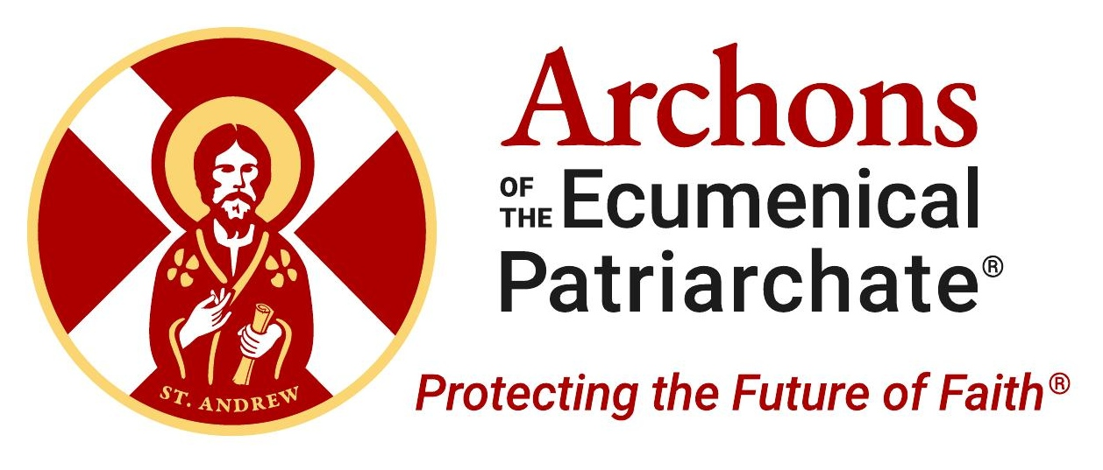 | ARCHON SUNDAY  Order of Saint Andrew the Apostle  Archons of the Ecumenical Patriarchate
Today we celebrate Archon Sunday
We are honored to welcome Archon ________________________, a member of the Order of Saint Andrew the Apostle and the Archons of the Ecumenical Patriarchate, who will be addressing our parish from the Solea at the conclusion of today’s Divine Liturgy, bringing greetings from His All-Holiness Ecumenical Patriarch Bartholomew, His Eminence Archbishop Elpidophoros of America, and National Commander Anthony J. Limberakis.
The Archons of the Ecumenical Patriarchate are dedicated lay leaders of the Orthodox Church, committed to protecting religious freedom and ensuring the future of the Ecumenical Patriarchate — the historic spiritual center of the world’s 300+ million Orthodox Christians.

Join Us After Divine Liturgy
Archon ________________________ will be available during Coffee Hour to answer your questions about the mission of the Ecumenical Patriarchate and the vital work of the Archons. Learn more and get involved via the Archons App and at www.archons.org.
Protecting the Future of Faith®

