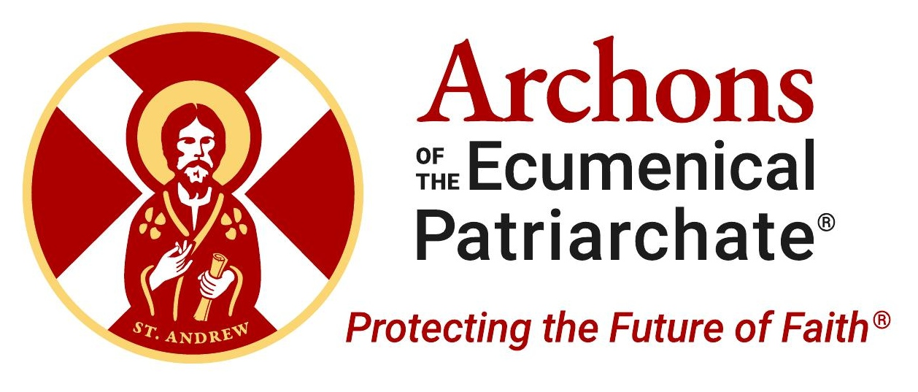
ARCHON SUNDAY 2026
Formal Address from the Solea
Ad-Lib Speaker Guide

OPENING
- Greet: Your Eminence • Reverend Fathers • Fellow Archons • Brothers & sisters in Christ — bringing greetings from His All-Holiness Ecumenical Patriarch Bartholomew, His Eminence Archbishop Elpidophoros of America, and our National Commander, Archon Anthony J. Limberakis
- Archon Sunday — reflect on the Ecumenical Patriarchate’s mission, and our mission as Archons to defend and promote it
- Our shared responsibility to support the Mother Church of Constantinople

WHAT IS AN ARCHON?
- Lay leader recognized by Patriarch Bartholomew for service to the Faith — using their standing to advocate with world leaders
- More than honor — a calling to protect and advance the Ecumenical Patriarchate
- 300+ million Orthodox Christians depend on this mission
Today, that mission is more important than ever.

THE LAST LINE OF DEFENSE
- Preventing the asphyxiation of the Ecumenical Patriarchate
- “That may sound dramatic — but it is true”
- Threats: political restrictions • confiscated property • demographic decline • surveillance • rising pressure from Russia
- Without advocacy — the Patriarchate risks marginalization on the world stage, and even its own existence
- 17 centuries of unity preserved through empires, wars, and exile
- A weakened Ecumenical Patriarchate = a weakened Orthodoxy
Never isolated. Never silenced. Never forgotten.

WHY THE ECUMENICAL PATRIARCHATE MATTERS
- Communion of self-governing Churches united in faith, sacrament & tradition
- Order within that communion — taxis
- Ecumenical Patriarch = first among equals — NOT a monarch
- Convenes councils • mediates disputes • safeguards conciliarity • grants autocephaly
- Nearly every autocephalous Church traces recognition through Constantinople — a status that runs with the land and can never be moved

WHY “ECUMENICAL” MATTERS
- Oikoumene — “the whole inhabited world”
- Universal ministry — beyond one nation, ethnicity, or government
- NOT merely bishop of a local Greek minority in Istanbul
- Spiritual leader & coordinating center of global Orthodoxy
- Turkey treats HAH as local — denies 17 centuries of history
Not about prestige — about preserving canonical order and unity.

WHY CONSTANTINOPLE ITSELF MATTERS
- People ask: why not just move? EP status runs with the land of Constantinople — it cannot be relocated. And there is only ONE Ecumenical Patriarch among all the Patriarchates — a title unlike any other.
- Constantinople is essential to Orthodoxy — not accidental
- Present continuously for 17 centuries — survived Byzantium’s fall, persecution, expulsions
- Moving = triumph of persecution • erasure of oldest continuous Christian presence
Its presence is a testimony to religious freedom and the enduring witness of Orthodoxy.

FIVE MAJOR CHALLENGES
- 1. Religious freedom in Turkey
- 2. Halki Theological School — closed 50+ years
- 3. Turkish interference in Patriarchal elections
- 4. Confiscation of Church properties
- 5. Refusal to recognize Ecumenical (universal) status — a status now also being challenged by Russia’s own ambitions

Religious liberty. Human dignity. Survival of the Mother Church.

THREAT FROM WITHIN ORTHODOXY
- One of the most serious threats now comes from within
- Moscow aligned with Russian state ideology
- Trigger: autocephaly granted to Orthodox Church of Ukraine
- Moscow responded with hostility & attacks on Constantinople
- “Antichrist in a cassock” • “Devil in the flesh” — Patriarch of Moscow said nothing
- Religious language used to justify war • incursions into Ukraine & Africa • new AI-driven disinformation challenges

Not a jurisdictional dispute — a spiritual crisis.
- Orthodoxy was NEVER meant to serve empire or nationalism

WHAT THE PATRIARCHATE STANDS FOR
- Conciliarity over coercion
- Reconciliation over domination
- Dialogue, freedom of conscience, unity in Christ
- The Mother Church belongs to the whole Orthodox world
As Archons — we cannot remain silent.

CALL TO ACTION
- 1. PRAY — for Patriarch Bartholomew and the Mother Church
- 2. STAY INFORMED — learn the challenges, share the story
- 3. SUPPORT THE MISSION — engage, advocate, give
  - Ecumenical Patriarch Bartholomew Foundation — invest in the future of Orthodoxy
  - Download the Archons App and visit www.archons.org to stay connected
When you support the Patriarchate, you support the spiritual heart of our Faith.

CLOSING
- Challenges are real — but so is our hope
- Survived persecution, exile, empires — because rooted in Christ
Final Prayer:
  - Strengthen Patriarch Bartholomew
  - Protect the Great Church of Christ
  - Guide toward unity
  - Grant us courage to serve faithfully
Thank you — God bless you all.

